# Project Go Shopping! (GDD)

## Brief

* Top-down view (Stardew Valley style)
* It has two characters: player and shopkeeper
* Player walks and interact with the game world
* Player can talk to the shopkeeper
* Player can buy, sell and equip items
* Player’s equipped items should be visible
* Items have icons and price tag

## GDD

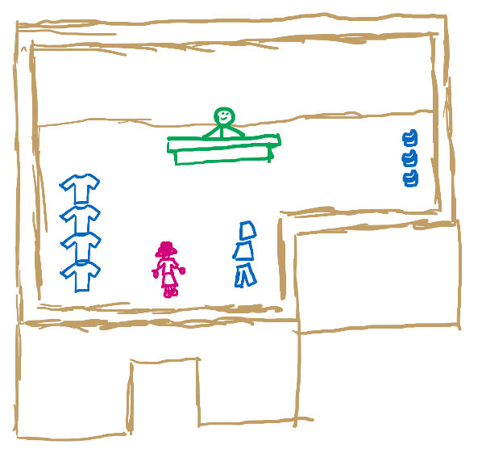

<IMAGE – SHOP’S INSIDE (not actual layout)>

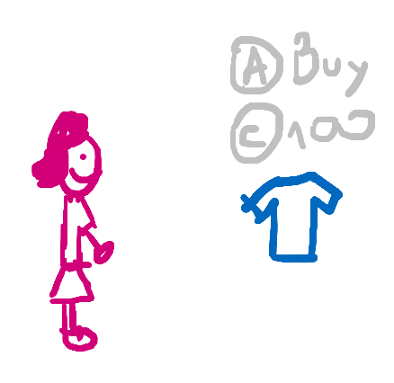

<IMAGE – EXAMPLE OF PLAYER FACING A ITEM>

When the player is facing an item that is at most **3 units away** from them, they should see the item price tag and the buttom prompt to interact with it.

When in shop, the player can face the item they want to buy and press the interact buttom, or talk to the shopkeeper.

When facing an item, they can press the interact buttom to buy.

If the player wants, they can talk to the shopkeeper and instead buy from him using his list. In this windows the player can sell items too.

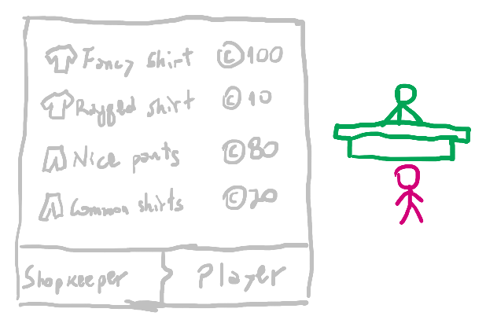

<IMAGE – BUY/SELL SCREEN (just an example)>

While talking to the shopkeeper, if the player clicks an item from their inventory, they sell it. If they click on an item from the shopkeeper’s inventory, they buy it.

The inventory is always open for the player to see.

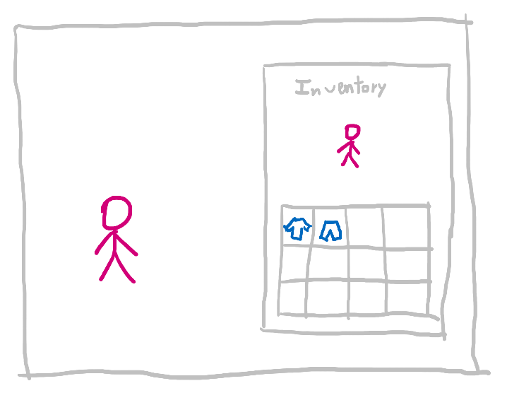

<IMAGE – INVENTORY SCREEN (it don’t have a player’s representation in game)>

If the player is not interacting with the shopkeeper (when the latter’s inventory is not open), the player can equip an item clicking on it. While equipped they see the clothing on their character, but not in the inventory.

If the player clicks on another item from their inventory (when not interacting with the shopkeeper), they unequip the previous item and equip the new one. The previous item appears again in the player’s inventory.

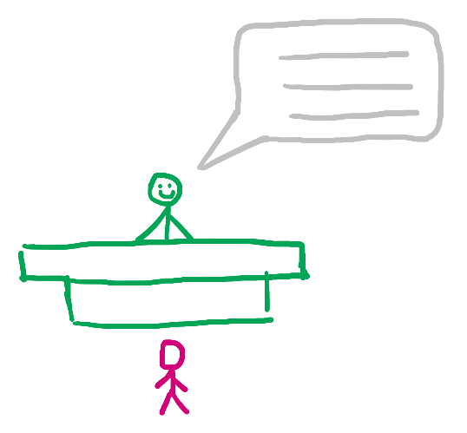

<IMAGE – INTERACTING WITH THE SHOPKEEPER>

To sell something while interacting with the shopkeeper, just click onto a player’s item to sell.

To buy something, the player can also interact to the shopkeeper and click onto an item from the latter’s inventory.

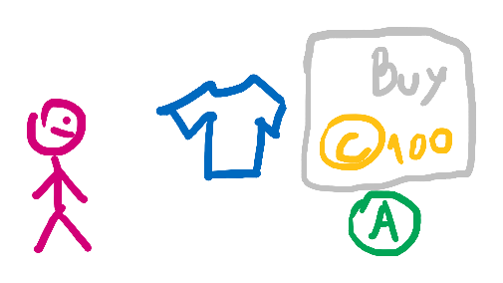

<IMAGE – PLAYER CLOSE TO AN ITEM IN THE SHOP SHOWING THE “BUY” HINT>

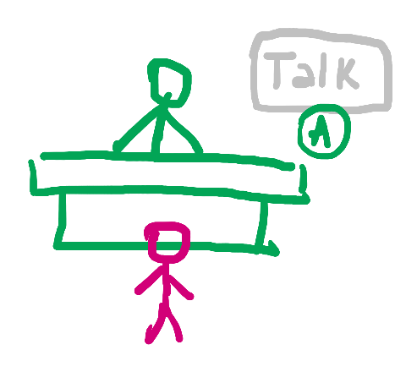

<IMAGE – PLAYER CLOSE TO THE SHOPKEEPER SHOWING THE “TALK” HINT>

When the player is within interaction range, a hint appears to show what happens if they press the interact buttom.

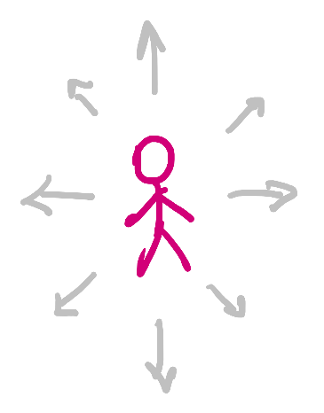

<IMAGE – PLAYER MOVEMENT INDICATION>

The player can move using arrow keys or WASD and interact using E or Space.

## Features

* Walk
* Interaction
* Inventory
* Equipment
* Trade